

Revised June 2023

Level 2 (4th Year)
Placement Information Booklet
2025/2026
This is an abbreviated version of the Practice Education Handbook and has been created to provide the ‘core information’ for placement.

B.Sc. (Hons.) Occupational Therapy School of Health Sciences
College of Medicine, Nursing & Health Sciences
University of Galway
Contents
1. Introduction 4
2. Contact Information 6
3. Process if a concern regarding a student 7
4. General Information about Level Two Placement 8
Timetabling of Practice Education 8
Learning outcomes 8
5. FACT SHEET 25: Guidance on 60/40 Placement in the COVID-19 context 10
6. Roles and Responsibilities of Practice Educator, Student, and Practice Education Co-ordinator/ Team 12
7. Educational expectations of Students at Each Level of Placement 13
8. Recommended Educational Approaches for Each Placement Level 14
9. Quality and Standards for Practice Education 15
Competency Standards 15
The Role of the Practice Educator 15
Good Practice in Practice Education 16
The Placement Process 17
10. 17
11. Essential Information Regarding Placement 18
12. Competency expectations when supervising a 4th year student 21
Quick reference to competencies 22
13. 22
14. Student Assessment on Level 2 Placement 23
The Level 2 Competency Assessment Form 23
Setting Expectations 23
15. The Competency Assessment Process 24
Halfway 24
Final 24
16. Devising a Learning Contract with your Student 24
17. Example topics for learning contracts 26
18. Supervision 27
19. Providing Feedback to the Student 28
Informal 28
Formal 28
Written 28
20. University Marked Practice Placement Assessments Overview 29
21. University Marked Practice Placement Assessment: 29
The Case Study 29
Type of Case Study 29
Practice Educator Role in the Case Study 29
22. The Case Study Process 31
23. Student Case Study Guidance 32
24. Case Study Fact Sheet 35
25. Roles in the case study 35
26. University Marked Assessment Item: 36
The Portfolio Pass/Fail 36
Practice Educator Role in the Portfolio 36
Student guidance on portfolio 36
27. University Marked Assessment Item: Student Reflection 38
Practice Educator Role in the Reflection 38
Student Guidelines for Reflection 39
Appropriate presentation and referencing 40
28. Practice Education Assessment Form – 4th year block 1 and block 2 (level 2) 41
29 Consent Form for Retention of Copy of Student Practice Education Assessment Form 56

Introduction

Dear Practice Educator,

Thank you for offering an Occupational Therapy Placement for a University of Galway student. This booklet has been designed to provide you with the core information that you need when educating a University of Galway fourth year student in practice.

In addition to the contents of this booklet, please find the full Practice Education Handbook for more detailed information on student placements and the Occupational Therapy Curriculum at University of Galway.

All forms are also available on the University of Galway Practice Education website in electronic versions.
Those not included as hard copies in this booklet are listed below. These include:

  - Site Profile
  - Student Orientation Checklist
  - Learning Contract Template
  - Supervision Forms
  - Concerns Exist Form
  - Student Record of Study Time
  - Practice Educator Feedback Forms (send to educators via survey monkey)
  - Student Feedback Forms
  - E-version of competency assessment forms
  - Calendar of placement

Other relevant documents that are essential reading for practice education are:
    - Guidelines for Good Practice in Practice Education (Therapy Project Office, 2008)
    - Practice Educator Competencies (Therapy Project Office, 2008)
    - CORU Standards of Proficiency

Any feedback on the resources provided or additional resources required to facilitate your role as Practice Educator is welcome.

With thanks,

Mary Rose Mulry
Lecturer of Occupational Therapy
Practice Education Coordinator
Discipline of Occupational Therapy,
University of Galway

Email: otpracticeeducation@universityofgalway.ie

Contact Information

Should you require advice or assistance prior to, during or after a student is on placement it is advisable that you contact one of the following:
  - The practice Tutor (if there is a tutor in your department) or Regional Placement Facilitator (if there is one in your region)

  - The Practice Education Coordinator at the University mmulry@universityofgalway.ie Should the PEC not be available please contact the Discipline Administrator jane.bowman@universityofgalway.ie
It is better to email in the first instance and you will be contacted back. Do not leave voice mail messages as this may delay communications.
  - If neither are available, please contact another member of the University of Galway staff who will be more than happy to deal with your query or concern (091) 492957 or email agnes.shiel@universityofgalway.ie

Process if a concern regarding a student

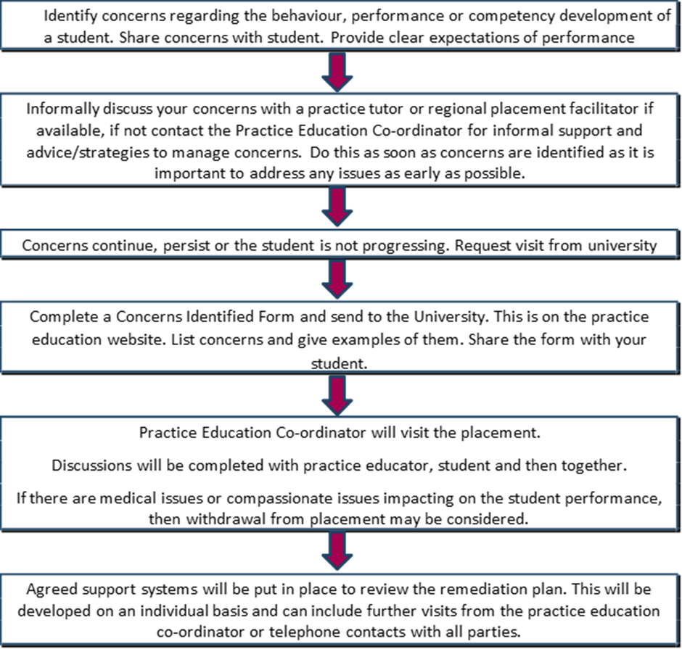

General Information about Level Two Placement

Timetabling of Practice Education

 | Aug | Sept | Oct | Nov | Dec |  | Jan | Feb | Mar |  | Apr |  | May | Jun | Jul
Y1 |  |  |  |  |  |  |  |  |  |  |  |  | 1 Week
Y2 |  |  |  |  |  |  | Placement Level 1: 1X8 weeks
Y3 |  |  |  |  |  |  |  |  |  | Placement Level 1: 1X8 weeks
Y4 | Placement Level 2  2 x 8 weeks

Learning outcomes

4th year Practice Education 3: OY4105 (Block 1)
This is the third practice education module and provides the opportunity for students to participate in the delivery of occupational therapy services in a work placement. Students will build on their previous learning in practice education placements, and at the end of the placement will evidence their attainment of practice competencies as defined by the CORU standards of proficiency.
Learning Outcomes
  - To demonstrate their application of the complete occupational therapy process and of adherence to the scope of practice in the practice education context to a practice standard under supervision from a qualified CORU registered (or equivalent) occupational therapist.
  - To demonstrate the application of theory, evidence-based practice and clinical reasoning to their practice-to-practice standard under supervision from a qualified CORU registered (or equivalent) occupational therapist.
  - To demonstrate adherence to professional standards, including the ethical, legal, and work based policies when working within a work placement to practice standard under supervision from a qualified CORU registered (or equivalent) occupational therapist.
  - To demonstrate being a self-directed learner who maximises opportunities to seek information to maximise the quality of service to the service user in this practice context to practice standard
  - To demonstrate progression of practice competence in relation to skills, knowledge, attitude and behaviour in accordance with the CORU Standards of Proficiency.

4th year Practice Education 4: OY4106 (Block 2)
This is the fourth practice education module and provides the opportunity for students to participate in the delivery of occupational therapy services in a work placement. Students will build on their previous learning in practice education placements, and at the end of the placement will evidence their attainment of practice competencies as defined by the CORU standards of proficiency.
Learning Outcomes
- To demonstrate their application of the complete occupational therapy process and of adherence to the scope of practice in the practice education context to a practice standard under supervision from a qualified CORU registered (or equivalent) occupational therapist.
- To demonstrate the application of theory, evidence-based practice and clinical reasoning to their practice-to-practice standard under supervision from a qualified CORU registered (or equivalent) occupational therapist.
- To demonstrate adherence to professional standards, including the ethical, legal, and work based policies when working within a work placement to practice standard under supervision from a qualified CORU registered (or equivalent) occupational therapist.
- To demonstrate being a self-directed learner who maximises opportunities to seek information to maximise the quality of service to the service user in this practice context to practice standard.
- To demonstrate progression of practice competence in relation to skills, knowledge, attitude and behaviour in accordance with the CORU Standards of Proficiency.

FACT SHEET 25: Guidance on 60/40 Placement in the COVID-19 context

Question | Guidance
What preparation have students had re: COVID-19? | Students have completed a range of online and reading materials on a) signs and symptoms, b) infection control c) contact tracing c) social distancing d) respiratory etiquette e) handwashing /handwashing competency f) donning and doffing PPE g) dress, hygiene and cleanliness h) putting on/taking off a medical mask i) evidence of immunisations and j) have signed a declaration of completion of all of these tasks. Use of laptops is permitted (no client information on if personal laptop)
What are the processes for student monitoring of wellness in practice education? | Students must complete the daily wellness APP from University of Galway 30 minutes before placement. This is monitored daily. Students must show their educator their green badge. If they have any symptoms, they must not attend placement and report to the student health unit/GP. Students that are tested negative for COVID-19 must self- isolate until 48 hours after resolution of symptoms Students are to apply the contact tracing system of the site. If students are identified as coming into contact with a person with COVID-19 they need to self-isolate and contact the student health unit/GP and follow the advice given which is to self-isolate for 14 days. They cannot return to placement without approval from the university who will have agreed the return of the student with the site. Students who are working on one or more site or working in health care outside of placement need to fill in a HSE self-risk assessment each time they move sites https://www.hse.ie/eng/staff/workplace-health-and-wellbeing-  unit/covid-19-guidance/covid-19-testing-protocol-for-healthcare-workers-moving-to-a-different-service.pdf
What is the role of the practice educator in the management of COVID-19 and student education? | Ensure that the student is familiar with all workplace expectations including the system for contact tracing. Any PPE used in the setting needs to be available for the student and social distancing maintained. Ensure that unsupervised presence of students in clinical areas (for example unaccompanied students seeing patients to practice hands on examination skills) is avoided or is very carefully controlled. Ensure that student(s) and teacher(s)/educator(s) presence in clinical areas is limited to events/time that have a specific focus on student education so that students are not present in clinical areas without a specific purpose. Ensure that no more than four people present for bedside teaching and similar situations, there should be no more than four people present at one time (including students, teachers/educators). In procedure/operation rooms there should be no more than one student at a time. Ensure that students and teachers/educators will be “bare below the elbows/bare above the wrist” when in clinical areas. Discuss with student a) use of public transport, b) activities outside of placement c) expectations of COVOD-19 workplace behaviour and conduct.
What is considered client tasks for a min of 3 days per week? | Client related tasks may include face to face work, telehealth, telerehabilitation, giving advice or information online or by phone, team liaison/networking, making referrals, discharge planning or evaluation, monitoring or evaluating interventions, shadowing other team members.
What is considered non client  related tasks, suggested for a maximum of 1.5 days per week | Students can be asked to complete a range of administration tasks including, report writing, investigation/research, prepare for face-to-face sessions, case study or portfolio. They can also complete projects for the service including information handouts, develop or evaluate programs, research evidence-based practice on a given topic but all must be related to placement. They can also participate in team CPD activities.
How do I prepare the student for the changing work environment? | Students may need to read/review/ be educated in new ways of working on placement including telehealth, online communications, tele rehabilitation or tele practice and other news ways of working in your setting. A list of resources that are relevant to your setting would assist the student in working in this new way. Some include AOTA and  WFOT https://www.wfot.org/resources/telehealth and https://www.wfot.org/news/2020/occupational-therapy-response-to-the-covid-19-pandemic.
How do I assess student competency? | Students can be evaluated in many ways. Observation of work practice including virtually. Through discussion, retrospective conversations. Ask the student to talk the process, i.e. step by step reporting on tasks, observations, reasoning and decision making providing their considerations, options, considerations of risk and research evidence. Discussing how they applied theory to practice regarding their clients this may include them presenting a full case report verbally or in writing. Checking of documentation for accuracy of content, correct measurement i.e. correct application and interpretation of standardised assessments or tools. Reading of the portfolio and application of Legislation and work-based protocols. Prospective conversation, asking the student to provide step by step planning/preparation of sessions or interventions, questioning using ‘what if’ scenarios. 360-degree appraisal, reports from other team members, service users or others they have worked with during the placement.  Commitment to self-development: Discussion in supervision completed work tasks in non-client time, and the work completed on learning contract goals. Being attentive to management of time, attention to detail, response to feedback, self-evaluation, use of initiative, and code of conduct/application of standards and procedures and compliance with HSE work practices/codes of conduct and workplace procedure. All competencies must evaluate and graded as evident or enhanced at the end of the  placement on the competency assessment form.

Roles and Responsibilities of Practice Educator, Student, and Practice Education Co-ordinator/ Team
 | Educator | Student | Practice Education Co-ordinator (PEC)/Team
Before Placement | Complete a site profile. Read the Practice Education Booklet. Prepare an orientation file for the student. Familiarise self with the assessment form and student assignments. Send the site profile and details to the student on contact. Sign the University of Galway Checklist/agreement form and return to the University. Review accommodations identified in reasonable adjustment plan if one provided. | Complete Placement passport, C.V. and letter of introduction, and send to the Practice Educator by the due date. Ensure all immunisations are up to date.  Read the Practice Education Booklet  Read the CORU code of professional conduct.  Read the site profile and complete pre-readings for the placement.  Develop a draft learning contract. | PEC: Prepare the student for Practice Education. PEC: Provide information to the Practice Educator on the student, and expectations of placement (i.e. relevant placement information booklet). PEC: Provide information on Garda Clearance, insurance, and assessment. PEC: Complete and forward reasonable adjustment plan. PEC: Have a signed University of Galway agreement form in place. Practice tutors (PT)and Regional Placement Facilitator (RPF): Assist educator to prepare
First Week of Placement | Discuss and apply reasonable adjustment plan if one provided by the PEC. Orient the student to the setting. Negotiate and agree a learning contract. Establish regular supervision using one of the University of Galway supervision forms and set weekly learning objectives. | Attend placement in appropriate dress. Negotiate and agree a learning contract. Maximize all learning opportunities.  Ask questions. | PT/RPF: Provide induction and Intro to the site and supports available in the area. PEC: Maintain Blackboard contact with all students.  PEC: Visit if needed. Maintain contact with student and practice educator
Half-way | Complete the halfway report. Contact the University if student not progressing.  Review and maintain the learning contract. | Complete the half-way report. Review and maintain the learning contract.  Listen to feedback and continue to maximize opportunities for competency development. | PT/RPF: Provide tutorials and support student and educator. PEC: Provide support via phone, email, skype or a site visit to both student and educator.
End of Placement | Complete final report. Meet with student and discuss report contents. (If keeping a copy of the competency assessment form, obtain consent (see template in Appendix Q) | Complete the final report. Self- evaluate if asked prior to students final marking. Thank educator for taking you as a student.4th year students can ask their educator to keep a copy of their assessment form for the purpose of providing a reference; refer to Protocol 14 & Appendix Q. Original copies of supervision forms are to be held in the student portfolio. | Collate final reports at the University. Review feedback on students.
After Placement | Complete feedback form and return to University of Galway | Complete feedback form and return to University of Galway.  Attend compulsory debriefing. | Collate feedback form and return to Practice Educators. Review feedback for quality improvements & implement change where possible.

Educational expectations of Students at Each Level of Placement

Level | Observation Placement | Year 2  Level 1 Placement | Year 3  Level 1 Placement | Year 4  Level 2 Placement(s)
Purpose of Placement | Introduction. | Practice | Practice and developing competency | Practice and Competency
Competency Level | Novice | Emerging | Consolidating | Competent
Supervision | Educator is a teacher: Participate in explanatory observations. Ask basic  Questions. | Educator: direct active supervision of student. | Facilitator: Collaborative approach to supervision of student. | Mentor: Consultative approach to supervision of student.
Application of theory | Educator Introduces basics of theory application. | Student discusses how theory is applied using one OT model/frames of references/treatment approaches. | Student can evaluate different models and defend the choice of a chosen model, apply it in practice with frames of reference and treatment approaches. | Student can defend and critically analyse the selection of models of practice applied in practice, as well as identifying the frames of reference and treatment approaches using best practice/evidence/ expert opinion or other relevant resources.
Students Autonomy | None. | Guided participation. | Developing autonomy in routine tasks. | Autonomous on allocated tasks, seeks guidance and supervision. Contributes to developments
Clinical Reasoning | None. Student listens to the educator’s reasoning. | Student listens and questions/explores educator’s reasoning. | Students participates in clinical reasoning discussions. | Student takes Unprompted lead on clinical reasoning discussions for exploration of alternatives and confirmation of decisions
Reflection | Reflect on new experiences. | Reflect on what did go well and not so well, develop a plan. | Reflect on self and others in events. Bring in best practice, develop a plan. | Reflect on events: performance, thinking and problem solving, bring in evidence-based practice and theory. Develop personal learning plans.
Competency Attainment | Understanding practice. | Developing basic skills. | Demonstrating skills in both reasoning and performance. | Prepare to enter work as a competent, critical and reflective practitioner.

Recommended Educational Approaches for Each Placement Level
Level | Observation | 2nd Year (Level 1) | 3rd Year (Level 1) | 4th Year (Level 2)
Focus of Placement | Exposure to a practice context. | Acquisition of basic practice skills and competence | Developing and consolidating competence and skills | Integration of skills and demonstration of competence to graduate.
Educational Approach | Teach. | Educate and provide opportunities for practice. | Facilitate guided participation in practice skills, students learn through learning by doing. | Relinquish control, allow student to develop and show competence and autonomy.
OT Practice | Student observes or participates with direct instruction. Allow some ‘hands on’. | Student begins to participate in all aspects of practice. Increase challenges in routine situations, and allow students to take responsibility caseload under supervision for straightforward, routine clients/patients | Student participates in all aspects of the OT Process. Set expectations that the student must begin to take responsibility for clinical decisions. Facilitate the student to deliberate on the complexities of practice and the role of the MDT/others. Trust the student with independent tasks and basic case management. | Student to organize, lead, choose assessments / interventions under supervision. Evaluate performance collegially. Allow to manage a caseload and identify strategies for managing complexity. Student to work collaboratively with other professionals /MDT and evidence person centred care.
Feedback. | Provide direct and specific feedback. | Provide a mix of direct feedback and asking student to identify what went well and what were the challenges. | Ask student to self-evaluate by stating what went well, what did not go well and what they would do differently next time. Facilitate this discussion and provide feedback on gaps identified | Ask student to reflect and self-evaluate before giving direct and specific feedback.
Reasoning | Use case narratives or stories and explain your thinking and decision making to the student. | Use narratives and case stories and discuss options (get students to choose correct options) for clinical decisions. | Use narratives and case stories but prompt student to identify their reasoning by asking them to describe explore/discuss options or alternatives to interventions. | Provide expectations that students will instigate clinical reasoning discussions pre and post client interventions
Theory | Prompt student to think about how the Person, their Occupation, the Environment, and their participation (PEO-P)  can be applied | Ask the student to report on a model or theories that may apply to clients in this practice context. Discuss their choice and give guidance | Ask student to analyse and present on an application of a model / theory relevant to a chosen client in this setting. The students should be able to compare and contrast models and argue for the relevance of their choice and apply the  model and theories to practice standard | Set expectations that a model of practice and theory will be or was applied to clients and give time for student to defend their choice and how it was applied in practice. Set expectations that best practice, research or opinion must be discussed in  their defence of their choice
Evidencing Learning | Prompt student to ask questions and provide options for answers, students can choose the one they think may be correct. | Ask students to tell you why a task is being completed / approached in a certain way. | Prompt student to communicate their thinking in pre and post intervention including possible options for the next action. Have discussions that allows the student to demonstrate their learning. Encourage students to seek out learning opportunities and report back | Expect the student to report on their thinking (options and choices), reflections, and self- evaluation of performance. Facilitate critical evaluation of their performance and identified plans to for improvements.

Quality and Standards for Practice Education

Competency Standards
The Occupational Therapy Registration Board of CORU have published the Standards of Proficiency for occupational therapists (2017). This document delineates the threshold standards that set by the registration board for entry to the registry. The standards of proficiency provide detail on the knowledge and skills that all graduates must possess at entry to the register. There are five domains
- Professional autonomy and accountability
- Communication, collaborative practice and team working
- Safety and Quality
- 4.Professional Development
- Professional knowledge and skills

All placements should show student progression towards the attainment of these standards and final placement should evidence attainment of these standards

The Role of the Practice Educator
Practice educator competencies were published by the HSE and The Therapy Project Office. In summary practice educators are expected to:
  - Ensure client consent for student participation in their work.
  - Treat students in a manner that respects their developing competence.
  - Acknowledge different learning styles, set learning goals and review in supervision weekly.
  - Teach, educate, supervise, mentor and evaluate students and to ensure opportunities are available for students to develop their competence in the practice context.
  - Give appropriate and timely informal and formal feedback.
  - Be an appropriate role model of professional conduct for the student.
  - Adhere to professional practice standard, legislation and policies relevant to the practice context.
  - Assess students fairly.
  - Communicate with the Practice Education Team.

Occupational therapy students carrying out their practice education placement do so under the following assumptions:
- Therapists’ primary responsibilities are to their patients/clients.
- Students’ presence will not hinder the work of the therapist.
- Students’ behaviour during the placement should not compromise the therapists’ credibility or relationships with other colleagues and staff.

Good Practice in Practice Education
There are also guidelines on good practice in practice education published by the HSE and the Therapy Project Office.
In summary these guidelines give guidance on:
- Preparation for Practice Education
- During Practice Education
- Post-Practice Education

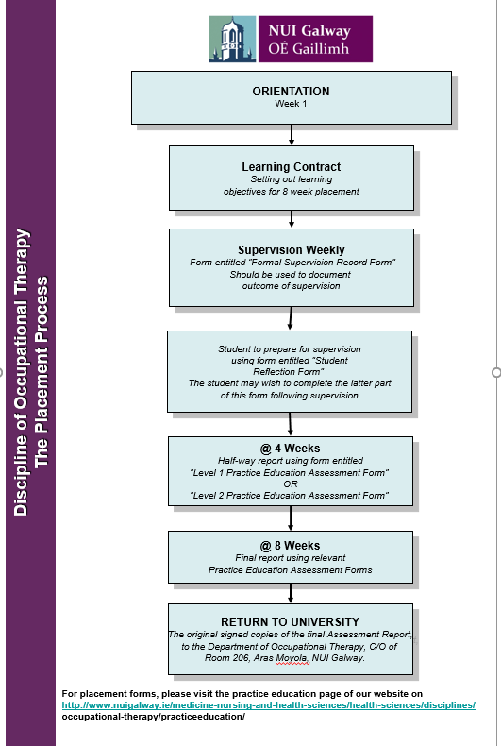
The Placement Process

Essential Information Regarding Placement

Hours
Students must work a minimum of a 35-hour week to attain the 1,000 hours to graduate. Students must have a minimum of a half hour lunch break. All hours worked, excluding lunch times are to be recorded on the competency form. Study time is included in the worked hours. Students will complete a record of their use of study time. Sickness or any other absences are not to be included as worked hours. Bank holidays or statutory days are also not counted as hours. A minimum of 250 hours is necessary to pass the placement.

Study Time
Students are permitted three hours study time per week. This time is at the discretion of the practice educator and does not have to be on a Friday afternoon. Students will need to complete a record of how they have used this time to meet AOTI requirements. This time must not be used for clinical duties (e.g. write progress notes), but for study related to placements. This may include general research or working on their portfolios or case study. The practice educator can identify goals for this study time in supervision sessions.
Sickness or Absence
- Attendance. Placement attendance is mandatory, Monday to Friday for the full duration of the placement. Practice education is continuous assessment and absence can adversely impact on competency development. Student should note that whilst there is a minimum requirement to attain 250 hours on placement, there is also a requirement to attain competency and this prevails over hours.
- Study time: Three hours study time is permitted and is included in weekly hours. This scheduling of this time must be negotiated and agreed with the practice educator. Whilst study time can be accrued, this can only be accrued for one-week i.e. so that one full day is facilitated every two weeks. No further accrual is permitted. The use of study time must be evidenced as study in the student’s portfolio.
- Sickness: If the student is sick and cannot attend placement, they must contact their Practice Educator. Student must explain that they are sick and provide some indication of their intended return to placement. Then, student must email the practice education co-ordinator and advise they are off sick. Students must provide a medical certificate if they are absent for three days or more.
- Unforeseen circumstances: If unforeseen circumstances occur e.g. a death of a family member, placement absence is negotiated with both the practice educator and the practice education co-ordinator. These will be managed on a case-by-case basis.
- Medical appointments: Medical appointments and placement absence can be negotiated with the practice educator.
- Dental appointments: Dental appointments and placement absence can be negotiated with the practice educator.
- Other planned absences: Any other planned absences including weddings, must be pre-agreed with the practice education co-ordinator prior to placement beginning.
- Minimum absences: If more than three absences occur the practice education co-ordinator will be informed, and decisions made regarding student fitness to continue placement or the impact of absence on potential to demonstrate competency. Options that may be considered include cancelling the placement, or extension of placement days if the placement site/course commitments can accommodate same.
- Consequences of absence. Where a student is unable to complete a placement due to the number of absences, hours will not be recorded, and a repeat placement will be provided after a medical certificate has been received advising fitness for another placement. Repeat placements occur in the summer months. Students cannot progress to the following year without having passed all components of the academic program and that includes placement.

Code of Conduct
There is a new Code of Conduct for students attending the University of Galway which includes professional behaviour on placement. This can be found at Policies for Students / Polasaithe do Mhic Léinn - University of Galway. Breaches of this Code and of any University regulations make students liable to the imposition of sanctions.

This code states that:
Student behaviour in the wider community reflects on the University and the University will deal with complaints brought by members of the public to the University in respect of student behaviour under this Student Code of Conduct. Students are obliged to behave in a manner that will not bring the University into disrepute when outside the precincts of the University. This includes, but is not limited to, a student’s place of residence and during a work placement, field work or clinical practice.

Students will behave in a professional manner at all times. They will be particularly cognisant of issues relating to confidentiality and will be careful to respect the client/professional boundaries that exist in a therapeutic relationship. Students should be familiar with and will abide by the Association of Occupational Therapists of Ireland Code of Ethics and Professional Conduct Publications | The Association of Occupational Therapists of Ireland (aoti.ie) and the Codes of Conduct as published by CORU Codes of Professional Conduct and Ethics - Coru

Punctuality and Time Management
Students are expected to arrive for work on time and be fit for work. Punctuality and appropriate time management are expected work-based behaviours. Students who persistently arrive late and have been given warnings, may fail the placement due to poor time management. Students who are not fit for work should be sent home and the Practice Education Co-ordinator contacted.

Garda Clearance
The National Vetting Bureau (Children and Vulnerable Persons) Act 2012 stipulates that a written agreement must be in place between University of Galway and the placement provider in line with section 12(3A) of the act. Per the agreement, upon receiving the formal consent of its students, University of Galway will apply for Garda Vetting from the National Vetting Bureau in respect of the students, on its own behalf and on behalf of your organization and undertakes to inform the organisation that the Garda Vetting has been undertaken.
Where no agreement is signed, the placement provider is responsible for seeking Garda vetting for students. (See Appendix A for HSE Agreement and Appendix B for other placement providers). Students must sign consent forms to share their disclosure forms on placement (Appendix C).

Use of Private Cars by Students
It is the policy of the University that students do not carry service users in their cars. If students are required to use a car to travel during placement, students should have appropriate business class insurance. Some placement providers may have local car insurance requirements. Practice Educators need to advise the student of these prior to beginning placement. Students must identify if they can use cars on placement in a form completed prior to placement allocations (Appendix D).

Dress Code
Practice educators are asked to define the dress code requirements when completing the site profile. Students are expected to wear the standard uniform for occupational therapy students at University of Galway whilst on placements where a uniform is worn by the practice educator or by the clinicians working in the department. In placements where a uniform is not appropriate students must wear their student’s name badge at all times unless advised not to by the practice educator. Students will adhere to the dress code of the practice placement. It is important that students become aware of the need to create the appropriate professional image in order to gain credibility and the confidence of their clients. The following dress code has been drawn up to assist them in this:
  - No jewellery may be worn with the exception of wedding rings and a single stud earring in each earlobe. Wrist watches may not be worn on physical hospital placements in line with HSE infection control policy.
  - Long hair should be tied back. Clothes should be clean and pressed. Clothes should be appropriate to working in the placement environment e.g. smart trousers/skirt/dress etc.
  - Footwear should be suitable for moving and handling.
  - Jeans, leggings or skirt less than 18’’ long must never be worn. Perfume or aftershave should not be worn as it can cause an allergic reaction with some clients.

Students with Disability
Student registered with University of Galway Disability Services will have a reasonable adjustment plan for placement. This will be sent to the practice educator by the practice education co-ordinator prior to placement. Students do not have to disclose their disability and must meet the competency requirements of the placement.

Retention of Student Records
All student records must be returned to University of Galway at the end of placement. Copies of final assessment forms can be retained with the written consent of the Fourth-Year student only. Students will retain original copies of their supervision forms in their portfolio. Refer to Protocol 14 for the full Retention of Records Policy and Appendix Q for the associated consent form. This can also be found at the end of this booklet.

Competency expectations when supervising a 4th year student
This fact sheet defines expectations of student performance during the eight weeks. Although each student may progress through these stages differently, the final outcome should be that the student can work competently under supervision.
Week one | To include
Week one: Supervision agreement, service orientation, and review learning objectives | Make an agreement on how you are going to supervise your student. A protected time for formal supervision is often of value once a week and informal supervision ongoing throughout each day. Be explicit that both will provide feedback on performance. Each student will have brought a learning objectives form. Ensure that these are relevant to the placement. It can be worthwhile to break these down into weekly objectives so that both the student and supervisor are clear how the student is progressing to meeting the agreed objectives or building on them if achieved.
Week two | To include
Week two: Observing, reasoning, and beginning to participate under close supervision | In week two, students should be able to observe the work of the occupational therapists and begin to use procedural reasoning to explain to the supervisor their understanding of occupational therapy intervention. Students should be investigating and reporting on diagnoses. They can begin to gather information on referrals and should be developing pragmatic reasoning of how the occupational therapist works in an inter or multi-disciplinary team. They should be showing the ability to develop therapeutic relationships with clients.
Week three | To include
Week three: Participating under supervision | In week three, students should be beginning to participate in occupational therapy interventions with supervision. They should be developing communication, assessment and documentation skills appropriate to the practice context. Students should be reflective of their performance in supervision and seek guidance on areas for improvement. They should be familiar with the main assessments/ treatments used in the setting.
Week four | To include
Week four: Participating with distant supervision | In week four, students should be developing their confidence in participating in occupational therapy intervention. They should be practicing their communication, intervention and documentation under supervision. They should be demonstrating an understanding of common diagnoses but also begin to be able to identify challenges in addressing OT needs in the work setting. They should be able to discuss the relationship of theory to the practice setting.
Week five | To include
Week five: Developing practice competence | In week five, students should be developing their competence. They should be completing all aspects of occupational therapy intervention under supervision. They should be able to explain their professional practice reasoning including their judgment, problem solving and decision making. Supervision should be a mix of case-based discussion and the exploration of different perspectives to develop their case-based thinking. Students should be discussing evidence base practice with the supervisors and reflecting on the challenges of service provision in the practice context.
Week Six | To include
Week six: Consolidating practice competence | In week six students should be demonstrating an ability to complete occupational therapy interventions and may need to be challenged to lead on assessment and intervention under supervision. They should be able to manage some cases/clients and utilise supervision for assistance. They should be more independent and be able to advocate for the client, communicate formally to team or other stakeholders such as families. They should implement workplace policies and procedures to the correct standard.
Week Seven | To include
Practicing as a therapist | In week seven, students should be able to demonstrate that they can be part of the team, practice as a therapist under supervision and complete the daily routines and expectations of a fourth-year student in this context; this includes time management and working to the pace expected of a student.
Week Eight | To include
Practice competence. | In week eight, students should be able to demonstrate that they can consistently work in this practice context with a range of clients. They should clearly be able to identify their strengths and what they need to further develop. They should be able to use a range of strategies to meet their developmental needs.  They should be independent thinkers and demonstrate their skills and abilities in working and managing a caseload under supervision.

Quick reference to competencies
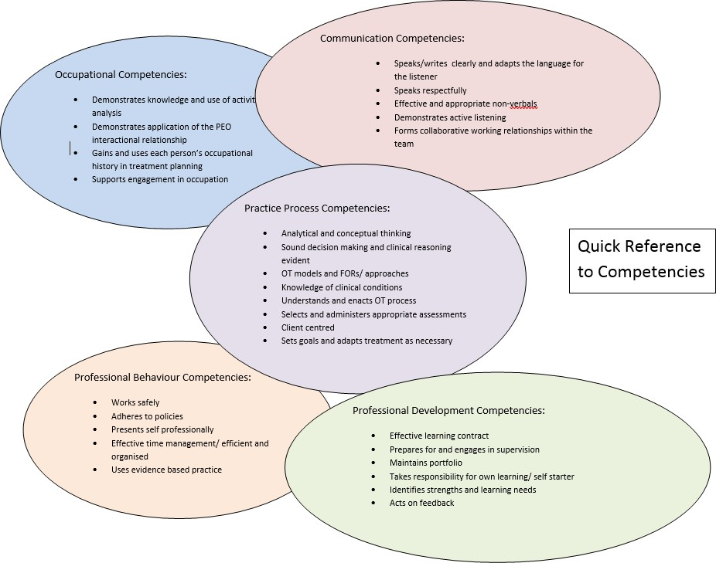

Student Assessment on Level 2 Placement

The Level 2 Competency Assessment Form
The student is assessed using the Level 2 Placement Assessment Form by the Practice Educator. A hard copy version is in the Appendix of this booklet. Refer to the Practice Education website for an electronic version.

Setting Expectations
The Level 2 Competency Placement Assessment Form enables competencies to be individually assessed in a variety of work settings. Prior to the placement it is appropriate to review the form and provide examples of how the competency can be evidenced in your work setting. Provide these to your student so that they know what you expect from them in this placement. Some examples are given below. Also see Appendix 2.
 | Not Competent |  | Competent
Competencies | Not Evident | Emerging | Evident | Enhanced
Work safely in compliance with health and safety regulations as specified in the practice setting.
Example:
Leads on risk assessment
Identifies and applies health and safety regulations in this setting (i.e. hand washing, moving and handling, reporting of incidents, lone working, management of challenging behaviour, management of materials etc.)
Adhere to the ethical, legal, professional and local practice contexts that inform occupational therapy practice.
Example:
Makes appropriate ethical decisions when prioritising and managing a caseload
Adheres to local procedures, policies or protocols (i.e. standard operating procedures)
Gains and records client consent
Adhere to confidentiality as described in the local context.
Example:
Maintains confidentiality when managing a caseload

The Competency Assessment Process

To pass this placement all competencies must be either evident or enhanced. Students must be assessed at halfway and at the end of the placement using the Level 2 Competency Assessment Form.

Halfway
It is important that halfway assessment must be completed at the halfway point. Feedback should be given on areas to be developed so that students have time to work on areas of ‘emerging’ or ‘not evident’ competency. It is normal for students to have many ‘not evident’ or ‘emerging’ grades at the halfway point as competencies may yet not have been consistently demonstrated.

Final
It is recommended that the final assessment is not given on the last day so that students have time to reflect and review the content of the competency form and complete student sections. The original signed competency assessment form must be returned to the university. A student who does not consistently amend behaviour which is not appropriate to practice should be awarded an emerging grade.

NOT COMPETENT | COMPETENT
NOT EVIDENT – This competency was not demonstrated. | EVIDENT – This competency was consistently demonstrated.
EMERGING – This competency was not consistently demonstrated. | ENHANCED – This competency was consistently demonstrated. The performance was to a high standard.

Devising a Learning Contract with your Student

The student should bring a draft learning contract. The contents should be negotiated and agreed in the first week of placement and reviewed in supervision. The learning contract focuses the learner on their goals of the placement. A sample format for the Learning Contract is included in Appendix E of the Practice Education Handbook. A bank electronic learning contract can be found on the University of Galway website

Learning Contracts should specify the following:
  - The learning objectives or goals to be achieved
  - The support required and resources available
  - Details of how learning goals or objectives will be addressed
  - The timeframe within which goals or objectives should be achieved
  - The nature of the evidence that will indicate when goals or objectives have been met
  - The criteria to be used to assess the evidence
  - The signatures of the parties involved in the contract.

Twelve steps to working through a learning contract:

Step 1: The Learner’s needs or gaps in knowledge or skills are clarified: student identifies strengths, knowledge and skills and identifies weaknesses in relation to current placement. Practice educator can provide guidance.
Step 2: Learning outcomes are defined: Agreeing on what will be achieved in a defined timescale.
Step 3: Learning opportunities and resources needed to attain outcomes are identified e.g. literature, technology, members of the multi-disciplinary team etc.
Step 4: The process by which learning is to occur is specified in a plan. Plan reflects learning strategies to be used.
Step 5: Responsibilities of the people involved are detailed.
Step 6: Timeframe for completion is determined: Practice educator facilitates the student to set a realistic timeframe.
Step 7: The criteria against which the achievement of goals is to be assessed are recorded: A checklist for the evidence required to ensure that the terms of the learning contract are fulfilled.
Step 8: The learning contract is signed by both or all parties: shows commitment to a contractual activity.
Step 9: The learning activities are undertaken: new themes or interests may emerge through original outcomes should not be discarded.
Step 10: The contract is revisited and revised as necessary as the plans progress.
Step 11: Outcomes are evaluated against the recorded criteria: Good to consider what helped or hindered learning process.
Step 12: Future needs may indicate a renegotiation of the contract.

Example topics for learning contracts

Level | 2nd Year (Level 1) | 3rd Year (Level 1) | 4th Year (Level 2)
CORU: Professional Autonomy and Accountability  Role performance: Time management | Is able to prioritise tasks with assistance and complete work tasks in the time frame given. Understands the role of others who tasks are  delegated | Is able to manage small caseload for setting. Is able to prioritise work tasks appropriately and complete essential tasks in a timely fashion. Can identify tasks that  need to be delegated | Is able to manage part of a clinician’s caseload and work tasks to practice pace. Is able to prioritise and complete work tasks in required timeframe. Is  able to delegate appropriately
CORU: Professional Autonomy and Accountability  Role performance:  work tasks | Is able to use initiative in mundane and routine tasks  e.g. setting up a room, organising clinics | Is able to use initiative on basic work tasks, e.g. doing a chart review, completing screening etc | Is able to complete work tasks independently and without prompting e.g. organising clinics
CORU: Professional Autonomy and Accountability Policies and procedures | Reads and can identify the application of policies and procedures | Can apply policies and procedures, particularly risk assessment and health and safety procedures with guidance | Can apply policies and procedures, to the work setting and can discuss complexities of application in supervision
CORU: Communication, collaborative practice and team working  Team Communication | Is able to complete communication tasks with other staff informally | Is able to communicate formally with other staff, patients, carers, families and services on routine matters | Is able to communicate informally and formally with other staff, patients, carers, families and services on matters
CORU: Safety and Quality  Judgement, decision making: Thinking Skills | Is able to demonstrate an understanding of clinical decision making through explanation in supervision | Be able to provide other options when discussing clinical decision making and give sound thinking on why other options may be relevant | Will be able to initiate and lead on one innovative or new decision making based on evidence- based practice that will benefit the service /service users
CORU: Professional Knowledge and Skills Task performance | Be able to complete simple and straightforward skills e.g. assessment/s under supervision | Be able to complete tasks with guided participation e.g. do assessment/s with some complexity with supervision. | Complete autonomously e.g. do assessment/s with some complexity but able to report to educator
CORU: Professional Knowledge and Skills  Knowledge: Theory | Describe or explain theory relevant to the setting | Select an appropriate model of practice/theory and apply their choice to clients | To be able to integrate theory into everyday practice
CORU: Professional Knowledge and Skills Knowledge: Evidence based practice | Be able to identify one/two key research used in this setting | Be able to apply evidence-based practice in discussion with practice educator in supervision | Be able to analyse, critique, select and apply evidence in practice by leading discussions in supervision
CORU: Professional Development Personal Development: Learning Behaviour | Identifies relevant questions and uses reflection with educator to develop plans of development | Seeks confirmation of tasks to be completed. Active reflector with educator with detailed and relevant onward planning to develop | Seeks guidance and supervision as needed with insight into abilities, strengths, needs and weaknesses. Evidence  reflection in supervision with planning
CORU: Professional Development Attitude to feedback | Is able to listen to feedback from educator and voice a plan of changes to be made | Is able to listen to feedback from educator and others. Is able to voice a plan, and implement that plan of changes to be made to practice | Is able to self-evaluate performance and seek clarification or elaboration from educator and others. Is able to voice a plan, and implement that plan of changes to be  made to practice

Supervision

Supervision is an integral part of Practice Education for students. The educational and supportive supervisory functions of Practice Education supervision are closely aligned to those of professional supervision for qualified staff therefore, the experiences that students gain from being supervised and of taking on the responsibilities of being a supervisor begin early in an Occupational Therapist’s career (Professional supervision in occupational therapy, AOTI, 2010).
  - Supervision should be scheduled as a formal meeting weekly. Students must retain all supervision records and are expected to include 6-8 completed and signed supervision forms in their portfolio. Supervision forms can be handwritten.
  - Students should prepare new items for the supervision meeting as well as be prepared to report on actions from the previous meeting. These can be based on student reflections or informal feedback given since the last meeting.
  - The learning contract should be an integral part of supervision and should be reviewed or added to in the supervision meeting. Supervision is collaborative with both parties setting objectives, talking and planning future actions.

Supervision can be separated into the following sections:

Competency Review (Learning and Development): Progress from last week (including student self-appraisal from reflection), what went well, what were the challenges, what is to be completed by the next week and to what standard.

Development of reasoning and reflection (Developing practice thinking): Discussion on case study or other cases regarding the occupational therapy process, best practice, local policy and procedure, application of theory or duty of care. Encourage multiple perspectives including those of the service user to develop critical thinking skills.

Support and encouragement (Developing as a professional): Discuss personal challenges of working in this setting and strategies for management of self and as well as professional approaches to others. Practice Educators need to give space for students to be supported in managing emotions, stress and anxiety generated from new experiences on placement. They are being socialised into the profession so supervision can facilitate a sense of ‘belongingness’ to this placement and to the profession.

Accountability (Developing professional autonomy and confidence): Ask student to report on how they have used their initiative this week, such as what they have researched or read, what progress they have made on project work or what ideas they have for the development of new resources. Encourage and reinforce appropriate use of time in the workplace as they need to develop as independent and proactive professionals.

Supervision should be recorded on one of the University of Galway supervision forms. Actions should be specific and time framed. The supervision form can be found on the University of Galway practice education website.

Providing Feedback to the Student

Informal
Feedback is the most important part of educating students in work settings. It is highly valued by students but they prefer realistic feedback, so be direct and factual. After a student contributes to an activity is the ideal time to give informal feedback. This can be an overall performance, verbal and non-verbal communication, content, knowledge, approach, pace or attitude to the activity. Tell the student what went well and give goals that they need to achieve next time… ‘you did this well on these aspects 1) 2) and 3) but next time I would like to see you work towards achieving 1) 2) and 3)’. Respond positively to feedback seeking behaviour. Sometimes it is useful to use the word ‘feedback’ as some conversational style feedback may not be perceived by the student as feedback on their performance. If a student is becoming over demanding of feedback and this is impacting on your workload, agree some ground rules or boundaries.

Formal
It is recommended that formal supervision is provided weekly. Ask the student to prepare for the meeting with a reflection on one or two activities they contributed to during that day or during a specific time period. Give them time to self-evaluate and evidence that they have heard your previous informal feedback and to describe the actions they have completed as a result of that feedback. Discuss how they can ensure they work towards achieving the performance goals. Discuss their proposed strategies to achieve these goals and their relevance to this placement. In other words, reflect but also ensure they are travelling towards achievement of competencies. The student will want realistic feedback. Give examples of good performance, their strengths and their skills. Identify areas that need to be addressed in future placements. Make a plan for the following week. This will ensure that the student is clear about the next steps that need to be completed.

If concerns exist be specific on these concerns. Give clear expectations on what they need to show or perform to indicate the achievement of an ‘evident’ competence grade at the end of this placement.

Written
Please use one of the University of Galway student supervision templates which can be found at Practice Education - University of Galway

University Marked Practice Placement Assessments Overview

University Marked Assignments

For Block 1 (August to October) placements there are two university marked assessment items:
- A 5500-word case study
- A portfolio

For Block 2 (October to December) placements there are three university marked assessment items:
- A 5500-word case study
- A portfolio

University Marked Practice Placement Assessment:

The Case Study
This provides the student with a third and fourth opportunity to produce a written case study report on a service user with whom they are currently working during Practice Education. The case is a typical service user of the practice education site and is chosen in collaboration with the practice educator. Guidelines for the case study are provided to the student by the University. The student is expected to apply their learning from their previous modules, in particular the Case Study and Evidence Based Practice modules, to deliver an advanced report. The student may present the case study to the practice education site team towards the end of their placement for formative feedback. This is negotiated between student and practice educator. See Appendix 1 for more information.

Type of Case Study
The service user selected should be typical of this practice context but have some complexities or challenges. The case study should reflect the knowledge, skills and attitudes of a student who is competent to graduate. Students should be demonstrating their independence in leading, planning, and delivering occupational therapy to this service user in this practice context but also demonstrate the ability to seek assistance appropriately when required.

Practice Educator Role in the Case Study
This marked case study and the reflection are part of a separate module to practice education and therefore the mark does not impact on practice education placements pass/fail grade. The case study is marked by the practice education co-ordinator.

The Practice educator has a responsibility to assist the student in identifying an appropriate service user for a case study. This should be completed no later than week five so the student has time to work with the person identified.
Practice educators should facilitate opportunities for the student to work with the chosen service user and discuss and explore application of theory, evidence-based practice and clinical reasoning with the student.

The practice educator can ask for a presentation of the case study in week 7 or 8. This is for formative feedback only. Practice educators are asked to sign a form regarding this presentation which should be completed by the student. This form identified the feedback that the student received on their presentation. If the practice educator has not asked for a presentation of the case study and this is acceptable, please could they sign the case study form for the student confirming that a presentation was not completed?

It must be noted that the case study is an academic piece of work, and therefore is the responsibility of the student to complete. Practice educators are not expected to mark or comment on draft papers.

The clinical practice of the setting is not critiqued or marked in this case study and students who fail this item have done so because they have not met the marking criteria. This is no reflection on the educator, the setting or practice in this setting.

The Case Study Process
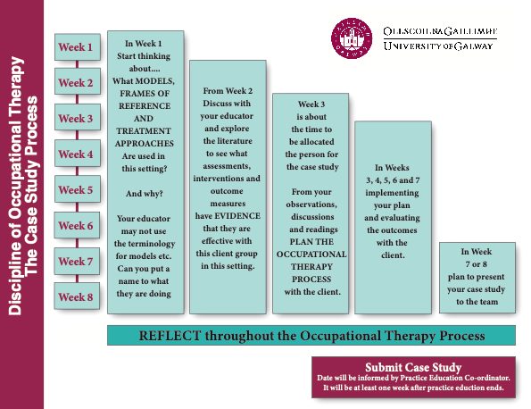

Student Case Study Guidance

Clinical reasoning
Clinical reasoning can be described as practice decision making. Many factors can influence practice-based decisions and students need to demonstrate throughout their case study but particularly at assessment and intervention the thinking that underpinned their decisions on how to progress their work with their client case study.

Case profile /demographic data
Details which could identify an individual must be changed or omitted. You may not use documents that identify the placement setting.
The following details may be included:
- Age
- Gender
- Diagnosis (Define, describe and reference to health professional standard)
- Prognosis
- Reason for referral to Occupational Therapy
- Previous relevant medical and social history
- Marital and family status
- Home and/or social situation and support services provided
- Occupation / employment

Occupational Model of Practice
The model of practice must be occupational, described and applied to the client at each step of the OT process but particularly at assessment and intervention. Rationale for the choice of the model and how it was applied to the case study must be reported.

Initial assessment
Results of initial interview and standardised and/or informal assessments with rationale for choice of assessment are to be included. Present results clearly and include interpretations of results. Alternative assessments that could have been used and reasons for not being used should be identified.

Occupational problems
A list of occupational problems and strengths must be presented and prioritized with client/carer consultation. These must be supported by the results of the initial assessment and /or knowledge of the condition. Occupational problems do not need to be referenced. No new information on the client should be presented in this section.

Goals of Intervention
These must be comprehensive and meaningful list of occupational SMART or COAST goals (not service goals) which are relevant to the setting and broken down into steps if relevant. Evidence should be provided of client/carer consultation and goals should be appropriately prioritized.

A clear rationale should be provided regarding goal choice or selection. There should be based on:
- occupational problems
- the results of the initial assessment
- knowledge of the condition

Search strategy
A relevant PICO or similar is provided that relates to sourcing evidence to inform one planned intervention. Clear search terms are identified. Inclusion and exclusion criteria should be identified. Boolean Logic applied to a range of relevant databases.

Critical appraisal of literature
Relevant literature should be selected and critically appraised in relation to aims, methods and outcomes of the research with view to level of rigour of the research so that the reliability and applicability of the research findings can be identified in relation the PICO or similar question. Full title authorship and dates of publications should be provided when each article is introduced.

Application of Policy or Legislation
Relevant national policy or procedures to be applied to ensure best practice and that the health and safety of the service user is maintained, examples include informed consent, duty of care, Sláintecare, risk assessment, etc

Discussion of application of evidence to case study
The relevance of the literature to the planned intervention for this client, the setting and the resources should be identified. This section should provide informed reasoning regarding the interventions planned. Discuss here how these articles applied if at all, to your client and your planned interventions. It is important not to try and fit the outcomes of the research to your client but give careful thought to their relevance, if any, to the intervention that your practice educator planned or delivered to the client.

Description of intervention sessions
This should include a brief description of each session with details of the goal(s) being addressed during the session, the treatment approach(es) and frames of reference (s)applied (define, describe and reference), the content of the sessions and evaluation of the session from the client and therapist perspectives. If many sessions were completed these can be grouped together.

Evaluation of intervention
Evaluation of intervention should include evidence of re-assessment where appropriate. There should be an evaluation of whether goals were met or not met with discussion of why this was the case where appropriate. In some cases (e.g. long-term clients) it may not be possible to evaluate outcomes. Where this is the case, a plan for evaluating overall outcome together with evaluation of the results of the intervention provided during placement will be sufficient.

Appropriate presentation and referencing
Referencing should be in Harvard Style as per University of Galway Library Guidelines.
Referencing should be from sources where possible published in the last ten years or the latest versions of textbooks.
Reference list is not included in the word count. There should be evidence of reading of relevant academic texts/published literature.

Appendix
The Appendix is not included in the word count and is not marked. The appendix is for supportive information. Key information like assessment results should be summarized in the main text. If only included in the appendix they will not be marked.

Penalties
Type of Breach | Penalty
Student includes copies of client records with or without  identifiers removed | Automatic fail (mark  of 35% is awarded)
Student identifies hospital or site | 10% deduction of marks.  Further 10% deduction for each  such incidence
Student uses a pseudonym throughout but uses the client’s real first name on one occasion e.g. “Mrs. X was seen in the OT Department. I obtained informed consent from Catherine . ”. | 10% deduction of marks.  Further 10% deduction for each  such incidence
Student uses a pseudonym throughout, but the first name of a client’s family member is visible on one occasion | 10% deduction of marks.  Further 10% deduction for each  such incidence
Client’s first and second name is visible in the case study. First and second name of a client’s family member is visible. | 20% deduction of marks.  More than one incidence is awarded an automatic fail.
Client’s name and address is visible in the case study | Automatic fail (mark  of 35% is awarded)
Client’s photograph or other highly identifiable information is visible e.g. hospital ID number. | Automatic fail (mark  of 35% is awarded)
Reference to unreferenced websites such as ‘Wikipedia’ or  ‘depression.com’ or sites specifically aimed at the public (rather than health professionals) | 5 marks deducted

Case Study Fact Sheet
During practice placements, students need to choose a case study client. This is a typical service user of the service and is chosen in collaboration with the Practice Educator. The service user selected should be a straightforward case and typical of the practice context, with no complexities or challenges for 2nd year case studies but in 3rd year, the case study should have at least one complexity or challenge and 4th year the case should have some complexities or challenges and should demonstrate graduating competence.

2nd Year PE | 3rd Year PE | 4th Year PE 3/ Block 1 | 4th Year PE 4/ Block 2
5,000 word written case study submitted  to the University | 5,000 word written case study submitted  to the University | 5,500 word written case study submitted  to the University | 5,500 word written case study submitted  to the University

The student may present the case study to the Practice Education site team towards the end of their placement for formative feedback only. The case study is marked by the Practice Education Coordinator and lecturers. The marked case study is a separate module to Practice Education and therefore the mark does not impact on the Practice Education pass/ fail grade.

Roles in the case study
Student Responsibilities | Shared | Practice Educator (PE) Responsibilities
The student has been provided with guidelines for the case study, (available in the Practice Education Handbook, Module Guides for Case study Appendix V and Y). | The case is chosen in collaboration with the Practice Educator by no later than week 5 of placement. | The Practice Educator should facilitate opportunities for the student to work with the chosen service user.
It is the responsibility of the student to complete the case study. |  | The PE should discuss and explore the application of theory, evidence-based practice and clinical reasoning with the student.
The student may present the case study to the Practice  Education site team. |  | The PE can provide formative feedback on the case study presentation. (Form to  be completed).
The placement setting is not critiqued or marked in the case study and students who fail the case study have done so because they have not met the marking criteria. |  | Practice Educators are not expected to mark or comment on drafts of the case study.
For 4th year the student should show independence in leading, planning and delivering OT to this service user but also seek assistance appropriately when required. |  | The PE should provide feedback to the student if they are getting too focused on the case study and remind them to avail of the learning opportunities placement offers and that they need to demonstrate overall competency in all assessment areas.

University Marked Assessment Item:

The Portfolio Pass/Fail

The portfolio is used to record the student learning and development while on practice education. The aim is to record information which will be useful for the rest of the course and on future practice education placements. The Practice Education Portfolio is submitted to the Practice Education Co-ordinator at the end of placement and is marked on a Pass/Fail basis. Students have access to a range of templates that they can use in their portfolio.

Practice Educator Role in the Portfolio
The practice educator should ask to see the students work on their portfolio in supervision. This shows the student learning on relevant aspects of the placement. The practice educator can comment on the quality of the portfolio as this is a marked item in the competency assessment form. Practice educators will be provided with all the templates that are provided for the students to complete for their portfolio and as part of placement learning, educators can select any of these templates and ask students to complete them within a specified timeframe.

Student guidance on portfolio
The portfolio must be submitted online, and handwritten forms scanned into the document. All material should be typed except for supervision forms which can be handwritten. The portfolio should be neat and professionally presented.

Practice Education Assessment Form – 4th year block 1 and block 2 (level 2)

This form is completed for 4th Year Students
(Developed in collaboration with the School of Occupational Therapy, University of Dublin, Trinity College)

(Please return completed report [not a copy] directly to the Discipline Office)

Name of Student
Name of Service
Type of Experience
Date of Experience (dd/mm/yyyy) | From | To
Name of Practice Educator
CORU NUMBER

Number of Days Absent
Total Hours Completed

OVERALL LEVEL OF ACHIEVEMENT
Competent | Not Competent  (Student required to repeat placement)

N.B. If a student is awarded a not competent grade (Not Evident or Emerging) for one or more competencies at the final assessment, this indicates an overall not competent level of achievement

Signature of Practice Educator
CORU REGISTRATION NUMBER
Email of educator
Signature of Student
SIGNATURE OF PRACTICE EDUCATOR
Both signatures are required.

Student Hours Log

Week (From – To) (dd/mm/yyyy) | Hours Completed | Initials of Practice Educator
1. to
2. to
3. to
4. to
5. to
6. to
7. to
8. to

To be completed by Practice Educator:

Sick leave hours taken: |  | Sick leave hours made up:
Sick leave certified: | Yes No | Sick leave cert forwarded to PEC*: |  | Yes No
Other leave/absence | Number of hours:  Reason:
Number of public holidays: |  | Total hours completed:
Signature of Practice Educator: |  |  | Date:
* It is the responsibility of the student to forward their sick certs to the PEC directly.

To be completed by Student:

Student Name and Number | Student Signature / Date

FINAL FORMATIVE ASSESSMENT

Name of Student:
Name of Practice Educator:

Summary of Practice Educator’s Comments and Feedback

Please continue comments on separate page if required.

Student’s Comments and Feedback

Please continue comments on separate page if required.
HALF-WAY FORMATIVE ASSESSMENT
Name of Student:
Name of Practice Educator:

Summary of Practice Educator’s Comments and Feedback

Please continue comments on separate page if required.

Student’s Comments and Feedback

Please continue comments on separate page if required.

Signature of Student
Signature of Practice Educator
Date (dd/mm/yyyy)

NOT EVIDENT – This competency was not demonstrated. | EVIDENT – This competency was consistently demonstrated.
EMERGING – This competency was not consistently demonstrated. | ENHANCED – This competency was consistently demonstrated. The performance was to a high standard.

 | Half-Way |  |  |  | End of Placement
 | Not Competent |  | Competent |  | Not Competent |  | Competent
Occupational Competencies | Not Evident | Emerging | Evident | Enhanced | Not Evident | Emerging | Evident | Enhanced
1. Demonstrate through either verbal or written communication an understanding of the meaning of occupation for the client and the client group or community.
2. Demonstrate through either verbal or written communication the person-occupation-environment relationship within the client’s context.
3. Analyse the use and adaptation of occupations for the client’s group and/or community.
4. Apply the therapeutic use of occupation to influence health and well-being of the client or group positively.
5. Support engagement and participation in meaningful occupation.
6. Demonstrate an awareness of occupational
justice and occupational deprivation for
the client and/or community.

Halfway Comments on OccupationAL Competencies

final Comments on OccupationAL Competencies

 | Half-Way |  |  |  | End of Placement
 | Not Competent |  | Competent |  | Not Competent |  | Competent
Communication Competencies | Not Evident | Emerging | Evident | Enhanced | Not Evident | Emerging | Evident | Enhanced
7. Demonstrate listening, verbal and non-verbal communication skills, both formally and informally.
8. Give and receive feedback in an open and honest manner.
9. Present oral information in a clear, concise and well-structured manner both formally and informally.
10. Write accurate, clear, contemporaneous records in accordance with legal and professional requirements.
11. Communicate effectively and in a professional manner with individuals.
12. Communicate effectively and in a professional manner in a group environment.
13. Form collaborative working relationships within interdisciplinary teams.
14. Use computer and/or communication
technologies appropriately in the
placement setting.
15. Provides information with intervention
options with professional opinion to the
service users, and/or health professionals
and/or relevant others.
16. Apply the principles of therapeutic use of self for client interactions.
17. Demonstrate the ability to provide
appropriate instruction and supervision
when delegating tasks to others where
appropriate.

Halfway Comments on communication Competencies

final Comments on communication Competencies

 | Half-Way |  |  |  | End of Placement
 | Not Competent |  | Competent |  | Not Competent |  | Competent
The Occupational Therapy Process Competencies | Not Evident | Emerging | Evident | Enhanced | Not Evident | Emerging | Evident | Enhanced
18. Select and apply appropriate conceptual and practice models to guide the occupational therapy process.
19. Demonstrate an integration of occupational therapy theory within practice.
20. Demonstrate an integration of relevant supporting evidence-based knowledge within occupational therapy practice.
21. Demonstrate a logical and systematic approach to problem solving and decision- making.
22. Demonstrate engagement in clinical reasoning to guide practice.

23. Demonstrate engagement in reflection and evaluation of practice.
24. Facilitate a culturally sensitive approach to practice.
25. Facilitate a client centred approach.
26. Facilitate the active participation of the client in the team.
27. Apply the principle of informed consent prior to and throughout the occupational therapy process.
28. Demonstrate the use of observation and interview skills to gather relevant information.
29. Select and administer appropriate standardised and non-standardised assessment tools.
30. Analyse the effect of the person, the environment and the occupation factors on activity and participation.
31. Collaboratively identify goals for intervention with the client (or people acting on his/her behalf).
32. Plan, grade, implement and modify interventions that are outcome based and relevant to the person’s goals.
33. Facilitate effective individual and/or group work interventions.
34. Demonstrate a working knowledge of group dynamics within the context.
35. Evaluate outcomes in collaboration with all parties.
36. Make onward referrals to other agencies or professionals to optimise responses to client needs.
37. Plan and implement discharge and follow-up.
38. Prioritise and manage a caseload either group or individual, under supervision.
39. Demonstrate an ability to understand and manage risk.
40. Applies the concepts of advocacy in
addressing the occupational needs of
individuals, groups and communities.
41. Select and use assistive technologies or
therapeutic modalities appropriately and
safely in client interventions.
42. Facilitates the service user’s management of their own health and wellbeing

Halfway Comments on Occupational Therapy Process Competencies

final Comments on Occupational Therapy Process Competencies

 | Halfway |  |  |  | End of Placement
 | Not Competent |  | Competent |  | Not Competent |  | Competent
Professional Behaviour Competencies | Not Evident | Emerging | Evident | Enhanced | Not Evident | Emerging | Evident | Enhanced
43. Work safely in compliance with health and safety regulations as specified in the practice setting.
44. Adhere to the ethical, legal, professional and local practice contexts that inform occupational therapy practice.
45. Demonstrate an understanding of policy and legislation on local practice context.
46. Adhere to confidentiality as described in the local context.
47. Present self in a manner appropriate to the working environment.
48. Respond constructively to changing circumstances and demands.
49. Demonstrate an awareness of personal and professional boundaries within practice.
50. Demonstrate a positive approach to clients and team members.
51. Demonstrate effective time management.
52. Demonstrate best use of resources available.
53. Demonstrate an ability to source, analyse and critique literature and research findings.

Halfway Comments on PROFESSIONAL BEHAVIOUR Competencies

final Comments on PROFESSIONAL BEHAVIOUR Competencies

 | Half Way |  |  |  | End of Placement
 | Not Competent |  | Competent |  | Not Competent |  | Competent
Professional Development Competencies | Not Evident | Emerging | Evident | Enhanced | Not Evident | Emerging | Evident | Enhanced
54. Take responsibility for personal and professional development.
55. Actively engage in supervision and request and utilise professional support.
56. Implement a learning contract.
57. Identify own personal and professional strengths and limitations.
58. Maintain a record of personal and professional development (i.e. portfolio)

Halfway Comments on professional development competencies

final Comments on professional development competencies

29 Consent Form for Retention of Copy of Student Practice Education Assessment Form

 | Discipline of Occupational Therapy, University of Galway

I (Print name)
Occupational Therapy Student at University of Galway, hereby fully and freely consent to my final assessment form for my Level Two Placement (Block 1) / Level Two Placement (Block 2) * being held by the Occupational Therapy Manager / Educator/ Tutor**

Name of Manager / Educator/ Tutor *

…………………………………………………………………………………………………

I understand and acknowledge that the form will be accessed by (Name of Manager / Educator/ Tutor*)

… only and will not be accessed by anyone else without my written consent. I understand that the form will be accessed for the sole purpose of providing a reference for me should this be requested on my behalf. I understand that this form will be held for a period of five years, will be stored in a secure locked cabinet at all times and that access to it will be restricted to those named above.

I note that I may withdraw my consent at any stage and that the purposes of holding my assessment and the reasons for accessing it in the future have been explained to me by

… and that I have been given an opportunity to discuss this with him/her.

I do not wish my assessment form to be kept on file. I understand that I if I do not agree that a copy of my assessment form is retained the Occupational Therapy Manager / Educator/ Tutor** of this service they will be unable to provide a reference if requested on my behalf due to lack of information.

Signed: Date:

WITNESS to signature of student and to fact that he/she has read the document and freely given his/her consent:

Signed: Date:

(Witness must not be the person who will have access to the file). * Delete as appropriate.
Please return the original copy of this form to the University.

